Post Doctoral Dissertation Theology

Policies of Church Management Best Practices

**FBI Partner - 1D8723**

Policies of Church  
Management Best Practices

as well as Malpractice and contributory negligence in business process management

**By**

**Dr. Dr. Prof. h.c. (habeas corpus) Jason Nygel Petersson; FBI Partner - 1D8723**

[First Amendment:](https://en.wiktionary.org/wiki/thealogy" \l ":~:text=thealogy%20(countable%20and%20uncountable%2C%20plural,e.g.%20from%20a%20feminist%20viewpoint.)

*[Congress shall make no law respecting an establishment of religion, or prohibiting the free exercise thereof; or abridging the freedom of speech, or of the press; or the right of the people peaceably to assemble, and to petition the Government for a redress of grievance.](https://en.wiktionary.org/wiki/thealogy" \l ":~:text=thealogy%20(countable%20and%20uncountable%2C%20plural,e.g.%20from%20a%20feminist%20viewpoint.)**[Thealogy](https://en.wiktionary.org/wiki/thealogy" \l ":~:text=thealogy%20(countable%20and%20uncountable%2C%20plural,e.g.%20from%20a%20feminist%20viewpoint.)*

[Post Doctorial Dissertation](https://en.wiktionary.org/wiki/thealogy" \l ":~:text=thealogy%20(countable%20and%20uncountable%2C%20plural,e.g.%20from%20a%20feminist%20viewpoint.)

[Thealogy](https://en.wiktionary.org/wiki/thealogy" \l ":~:text=thealogy%20(countable%20and%20uncountable%2C%20plural,e.g.%20from%20a%20feminist%20viewpoint.)

A Postdoctoral Dissertation submitted to the Faculty of the FBI Partner Institute, In Partial Fulfillment of the Requirements for the Degree of Doctor of Philosophy

Fort Worth, Texas

March 2023

ABSTRACT

**Policies of Church**

**Management Best Practices**

**as well as Malpractice and contributory negligence in business process management**

**Dr. Dr. Prof. h.c. (haebes corpes) Jason Nygel Petersson; FBI Partner - 1D8723**

A Dissertation submitted to the Faculty of the Graduate School, FBI Partner University, In Partial Fulfillment of the Requirements for the Degree of Doctor of Philosophy

Fort Worth, Texas

March 2023

ACKNOWLEDGMENTS **Dr. Dr. Prof. h.c. (haebes corpes) Jason Nygel Petersson; FBI Partner - 1D8723**

Throughout the writing of this dissertation, I have received a great deal of support and assistance. I would first like to thank my Proeffer Dr. Dr. Prof. Joachmin Fisahn; without his thorough feedback and patient guidance throughout this entire multi-year process, this dissertation would have gone nowhere. Colleagues, especially those whom I was able to see at conferences, listened to my ideas and provided very helpful feedback and critiques. My parents and siblings were instrumental in providing prayers, moral support, a sounding board. Ultimately, this dissertation would also not have been possible without the support of my wife, Micheala whose love, understanding, patience, and insight, truly surpasses my ability to properly articulate here

Omaha Beach in Normandy, France of Europe magnitude of gravity for the individual provides a sense of a simple person how small one is in reference to the amount of people of 9 Billion (looking at the Ocean and Skyline) and complexities of volume management. Church Management and policies as well as best practices that impact 1 person, 30-50 People or a larger town of 500-1000 people. The best practices for management and malpractices are described here for Church Management without extrapolation to State (20 Million) or Federal (300 Million) not including the World at 9 Billion.

1 Million x 1000 x 9 ( **9 Billion** ) – Pope, Francesco or Vatican Police **9 Billion**

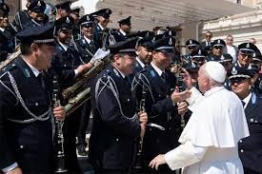

A §symphonies of Sunday Churches Management participation. There are three churches in this Municipal or county that are used as example in this area. Again the Normandy Beach or any beach with views of how small of an individual one is to realize 9 Billion People and management, to a Municipal 1M; 5,000 members. Gravity on the moon; gravitation waves (Normandy Omaha Beach) Dr. Dr. Prof. Jason Nygel Petersson, Saint Peter, Federal (US) Republic of Germany

# Table of contents

This section provides the table of contents for policies of church management

1. Overview Forward 1
2. Introduction Forward 2
   1. Analytical objective 1
   2. Mythology 2
   3. This Dissertation 3
   4. Conclusion 5
3. Services 10
   1. Conclusion 15
4. Sections 20
   1. Heating 25
      1. Offsite 30
      2. Onsite 35
   2. Music 40
      1. Offsite 45
      2. Onsite 50
   3. Reading 55
      1. Offsite 60
      2. Onsite 65
   4. Conclusion 70
5. City, State and Federal Financial Taxonomies 80
6. Business Process Malpractice 90
   1. Severe Contributory Negligence 100

6.1 Conclusion 115

7. 4. International Posts/Travel: None

https://www.mpimp-golm.mpg.de/5697/travel

8. Lectures:

8.1 FBI Partner v. Daimler Ag

8.1.1 God

8.2 Meiers v Morales ( Employee )

8.3 Meiers v Eric Ludwig ( Manager )

8.4 FBI Partner v. IBM and Damiler Ag

8.5 FBI Partner v. Accenture and Apple Inc

9. Research

10. Patents/Publications:

11. Analysis

11.1 Max-Plank Albert Einstein Institute ( <https://www.mpimp-golm.mpg.de/5697/travel>, https://www.aei.mpg.de/)

11.1.1 Newton Gravity

11.1.2 Max-Plank KE=hf

11.2.3 Albert Einstein E=mc²

11.2.4 Otto-Hahn nuclear chemistry and father of nuclear fission

11.3.4 Rutherford

11.2 Max-Plank Institute

1. Executive Summary 120
2. Appendix 122
3. Bibliography 125

Try It: Hit Enter after the first paragraph in this doc to get a new line. Then, go to the **References** tab, select **Table of Contents**, and choose a TOC from the gallery.

Overview

The overview this commercial property includes

Dissertation

Bomb Design Designing the bomb, or “gadget” as it came to be known, was not an easy task. Precise calculations and months of experimentation were required to obtain the optimum specifications of size and shape. For the bomb to work, sufficient fissionable material needed to be brought together in a critical mass, which would ignite a chain reaction that would release the greatest possible amount of energy before being blown apart and dispersed in the explosion. The simplest way to accomplish this, which became known as the gun method, brought two subcritical masses of fissionable material together at high speed to form a supercritical mass. This was done using conventional artillery 5 technology to fire one subcritical mass into the other. The gun method was used for the uranium–235 bomb. Los Alamos scientists discovered, however, that the gun method would not work for plutonium. Impurities in the plutonium would set off a predetonation after a critical mass had been reached but before the optimum configuration had been attained. The result would be an ineffective, wasteful fizzle. As an alternative, scientists turned to the relatively unknown implosion method. With implosion, symmetrical shockwaves directed inward would compress a subcritical mass of plutonium, releasing neutrons and causing a chain reaction. Los Alamos, working with the Army Air Force, developed two bomb models by spring 1944 and began testing them, without the fissionable materials, with drops from a B–29 bomber. The plutonium implosion prototype was named Fat Man. The uranium gun prototype became Little Boy. Field tests with the uranium prototype eased remaining doubts about the artillery method. Confidence in the weapon was high enough that a full test prior to combat use was seen as unnecessary. The p

Services

The church provides services

City, State and Federal Financial Taxonomies

The overview this commercial property includes

Sections

The church provides services and sections of similar content. The content of similarity would include for simple calculations of tables and additional further comparison and calculations. In specific reading, heating, and music. The matrices for similar services are shown here.

Matrices:

Church 1: Church 2: Church 3:

Reading, Heating, Music Reading, Heating, Music Reading, Heating, Music

Other: Scheudler(time:7am) Scheud(time:8am) Schedule(time:10am)

**New Service**

Calculation (New Service) i.e. Singing

Singing, Reading, Heating Singing, Reading, Heating, Music Singing, Reading, Heating, Music

Without abstraction and logical overlays of (I am going to church (regardless witch) to Sing then the malpractice or (Legislative, Judicial and Executive) violations in difference (or delta) for contributory negligence in business malpractice for each business process

**New Service (Policy)**

**§ Policy Set{**

**GOVEMTEN CODE §**

**§AGG ASSUALT ibm.damiler (policy) ibm.dmiler.moody.nonPoliceSeuciryt.nonPolcieLangaugLogica(Policy)**

**§**

**}**

[**https://www.ibm.com/docs/en/was-nd/8.5.5?topic=bindings-policy-set-settings**](https://www.ibm.com/docs/en/was-nd/8.5.5?topic=bindings-policy-set-settings)

Use this page to view or define general, application specific, or trust service specific bindings configuration information for policies that you can associate with the selected policy set.

I.e.

§1 Policy Set

§1.1 Policy 1.1 - Singing is only durung 5 Minutes 8:05-8:10

§1.2 Policy 1.2 – Signing and interpupt without the d…

Business Process Church 1 (Singing)

Texas Code, Public Disturbance

California Code, Public Diturbah

German State Code, Oeffentliche Stoerung

Federal Code US Code

Federal (US) Republic German Code

**Offsite**

Girlfrined name Chantal in Tunsian is Singer in English

Or Saenger in German

nonPoliceNSA.nonPoliceIncidentLogiccal

* HW5 Carrol Trucks

Grobache(Ibm.dmielr.visa.cybersourceh.emplyoe.michela.carroll)

Griflre is singer at Ghrohceo(pub)

**Onsite**

Business Process Church 2 (Singing)

Texas Code, Public Disturbance

California Code, Public Diturbah

German State Code, Oeffentliche Stoerung

Federal Code US Code

Federal (US) Republic German Code

Business Process Church 3 (Singing)

Texas Code, Public Disturbance

California Code, Public Diturbah

German State Code, Oeffentliche Stoerung

Federal Code US Code

Federal (US) Republic German Code

**Exiting Service (Reading)**

Business Process Church 1 (Reading)

Texas Code, Public Disturbance

California Code, Public Diturbah

German State Code, Oeffentliche Stoerung

Federal Code US Code

Federal (US) Republic German Code

Business Process Church 2 (Reading)

Texas Code, Public Disturbance

California Code, Public Diturbah

German State Code, Oeffentliche Stoerung

Federal Code US Code

Federal (US) Republic German Code

Business Process Church 3 (Reading)

Texas Code, Public Disturbance

California Code, Public Diturbah

German State Code, Oeffentliche Stoerung

Federal Code US Code

Federal (US) Republic German Code

**Exiting Service (Heating)**

Business Process Church 1 (Heating)

Texas Code, Public Disturbance

California Code, Public Diturbance

German State Code, Oeffentliche Stoerung

Federal Code US Code

Federal (US) Republic German Code

**Offsite:**

Auschwitz heaters German Federal Law and NATO UN Law

Gorbache(dj,linder)

**Onsite:**

Business Process Church 2 (Heating)

Texas Code, Public Disturbance

California Code, Public Diturbah

German State Code, Oeffentliche Stoerung

Federal Code US Code

Federal (US) Republic German Code

Business Process Church 3 (Heating)

Texas Code, Public Disturbance

California Code, Public Diturbah

German State Code, Oeffentliche Stoerung

Federal Code US Code

Federal (US) Republic German Code

**Exiting Service (Music)**

Business Process Church 1 (Music)

Texas Code, Public Disturbance

California Code, Public Diturbah

German State Code, Oeffentliche Stoerung

Federal Code US Code

Federal (US) Republic German Code

Business Process Church 2 (Music)

Texas Code, Public Disturbance

California Code, Public Diturbah

German State Code, Oeffentliche Stoerung

Federal Code US Code

Federal (US) Republic German Code

Business Process Church 3 (Music)

Texas Code, Public Disturbance

California Code, Public Diturbah

German State Code, Oeffentliche Stoerung

Federal Code US Code

Federal (US) Republic German Code

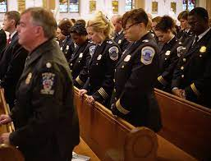

Voila! Word found all the headings in this document and added a TOC.

# Location and Travel Information

**Golm is a district of Potsdam, Germany, located on the outskirts of the city. Potsdam is the capital of the State of Brandenburg and is located south-west of Berlin. The Max Planck Institute of Molecular Plant Physiology is part of the Max Planck Campus in the Potsdam Science Park.**

#### **Public Transport**

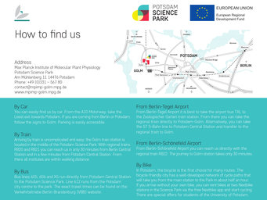

**From Berlin**  
During peak hours there is a direct train service between Berlin and Golm. The regional trains RB21 (*direction Wustermark*) and RB22 (direction Schönefeld Airport) run every half hour from Berlin Friedrichstraße via Hauptbahnhof, Zoologischer Garten, Charlottenburg, Wannsee and Potsdam to the station Bahnhof Golm (travel time approx. 35 minutes). Between 10 am and 3 pm please use the RE1 (direction Magdeburg) to Potsdam Hauptbahnhof and from there take RB21 or RB22 to Bahnhof Golm. It is a 10 minute walk from the station to the Max Planck Institute or one stop (bus no. 605 or 606).

**From Potsdam**  
The regional trains RB21 (*direction Wustermark)* and RB22 (*direction Berlin-Schönefeld Airport*) stop at Golm (travel time approx. 10 minutes). You can also take bus no. 605 or 606 to the Science Park Golm (travel time approx. 30 minutes).

**From Berlin Brandenburg Airport (BER)**  
The regional train RB22 (*direction Potsdam Griebnitzsee*) runs every hour between the airport and Golm (travel time: 34 minutes).

## **Air**

The airport Berlin Brandenburg (BER) is located at the southern periphery of Berlin city and is well connected to public transport (see above).

#### **Car**

**From Berlin**  
Take the southern city autobahn A10 and get off at “Potsdam Süd”. Stay on the B2 to Potsdam. First, follow the signs to Park Sanssouci, then to Golm. In Golm stay on the main road until you can see the Max-Planck-Campus on the right-hand side (greenhouses).

**From other directions**  
Take the western city autobahn A10, get off at “Least” and follow the signs towards Potsdam. After Potsdam-Grube turn left in the direction of Golm. After 500 m you will see the Max-Planck-Campus on the left-hand side.

Lectures

The malpractice and contributory negligence in business process management for Legislative, Judicial and Executive authority include are the following professorship conferences artifact libraries. As shown in Chapter 3 Section, Paragraph 1-5 the contributory negligence for each business, business department and person. For instance, 8.1 contains Federal Buero of Investigation Partner Consultation (similar to Department of Justice, Department of Labor and/or Department of Health and Human Services) Homicides integration into business process management (Chart (Usage of Homicide; Goethe, Wolfgang(lux)), in addition example 8.4 and 8.5 US Defense Homicide integration in international program management malpractice in policy.

8.1, 8.4, 8.5 do not include 8.2 and 8.3 that are person or employee specific (employee-to-employee) 8.2 and 8.3 (employee-to-manager) that examples include the purpose of lecture in professorship of Theology with specific execution in Law; Criminal Justice or Criminology.

8.1 FBI Partner v. Daimler Ag

Lux, Wolfgang; other Goethe, Wolfgang Dr. Dieter Zetsche

8.1.1 God

The Fedeal (US) Repulic of Germany former Vice Presint and Angela Merkel integration of

God withing FBI Homcide and case FBI Partner v. Damiler Ag. ( CAR; a commidy assumed givin

Severe interest to Germay adter 1945 Konrade Adenaure and Congress sonstitution implementation simpuar to following

United Nations Teaty 1945 Japan Nissan/Toyota/Lexus etc.).

God, academically shared in “Faust” Goethe, Wolfgang between the United States of America

And Federal(US) Repulic of Germany as the Createor of God; Geothe, Woflgang ( short: the person who

writes the defintoni of God as a charactor )

8.2 Meiers v Morales ( Employee )

usage of ibm.damielr.certificates.sexworker for malpatice in violatiosn PREA( Prions Rape Prevention Act)

8.3 Meiers v Eric Ludwig ( Manager )

usage of ibm.damielr.certificates.sexworker and ibm.dmielr.certieifa.pmp for civil code malpratices

8.4 FBI Partner v. IBM and Damiler Ag

FBI:HOMCIDE:William(Bill) Albright

8.5 FBI Partner v. Accenture and Apple Inc

Virus Court Mr. Rogers; Caption Cruch

# Research

**Golm is a district of Potsdam, Germany, located on the outskirts**

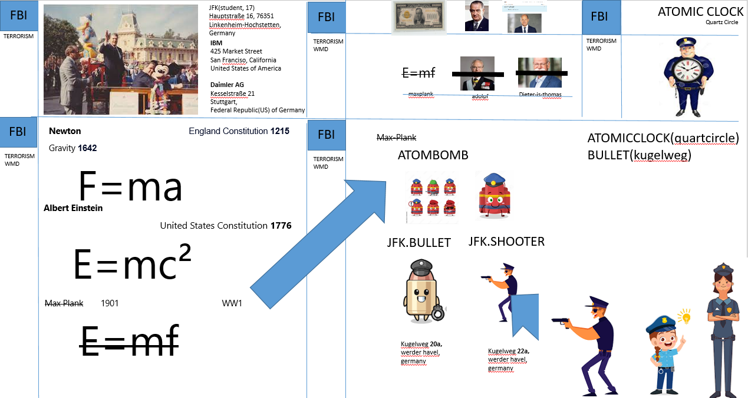

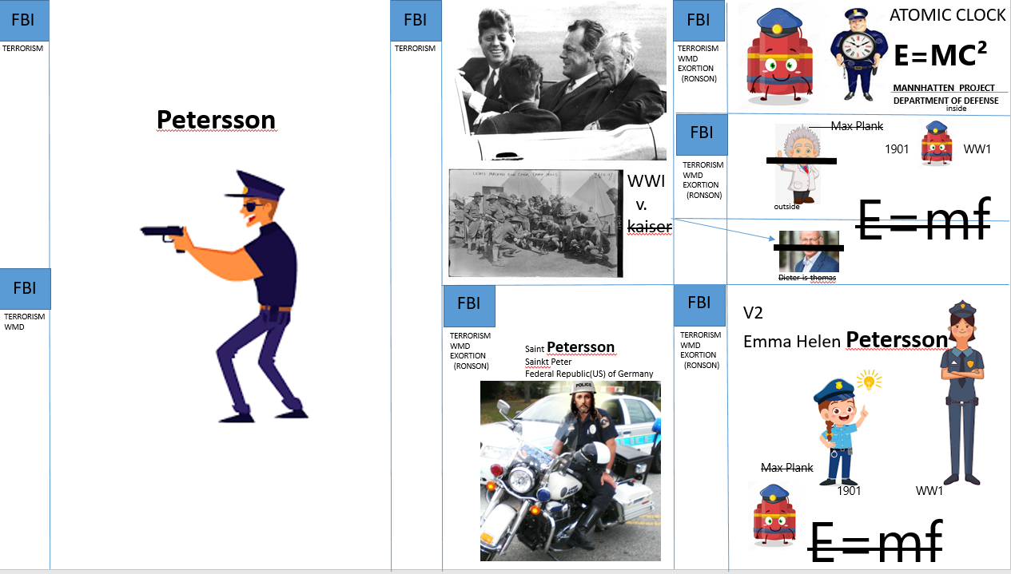

# Lectures

**Golm is a district of Potsdam, Germany, located on the outskirts**

# Business Process Malpractice

The heavy lifting doesn’t stop with creating a Church. As shown in the service matrices overlays of the average church throughput of people and process and technology, the [cfc] or identification of known issues include severe issue; that could be area specific. In example, the JFK incident or Auschwitz incidents of logical illegal transactions in violation against the constitution and law; judicial, executive as well as legislative.

As shown in Music, Pray, and Food tables of services logical non-area specific abstraction of services and conversation including (or inclusion) of other Municipals and counties for comparison. I.e. I walk out (Fabel: a remote cartoon view appealing to reader for reflection) the church in Auschwitz and in Fort Worth, Texas they would or may believe that there is a contextual problem; although this is routine of every Sunday or week.

2023

6.1.1 Malpratice Chart Weekly, Monthley and Yearly

2024

6.1.2 Malpratice Chart Weekly, Monthley and Yearly

as well as Malpractice and contributory negligence in business process management

* Generated specific violation in Legislation Federal Republic of Germany and United Nations Treaty of 1945
* US CODE §1751 Homicide of President of Presidential Staff, i.e. John F. Kennedy or Logical Barack Obama

# 11.1 Analysis C:\Users\User_Kiosk_LL_Public\AppData\Local\Microsoft\Windows\INetCache\Content.Word\atom-2.jpg

11.1.1 Newton Gravity 1642  England Constitution **1215**

F=ma

11.1.3 Albert Einstein United States Constitution **1776**

E=mc²

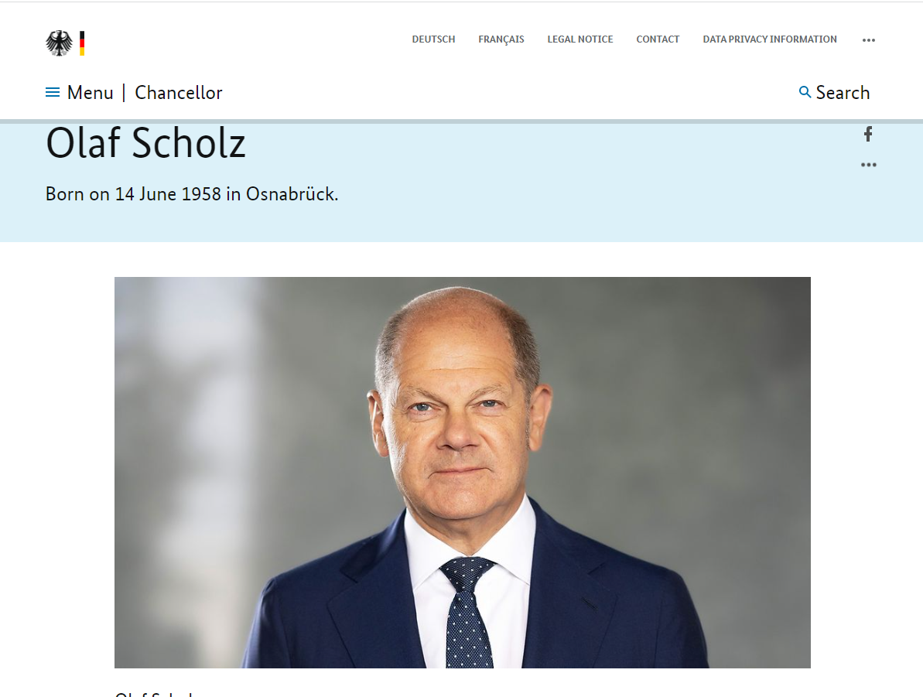

Federal Republic (US) of Germany (FRG, BRD) Constitution **1945**

11.1.2 Max-Plank 1918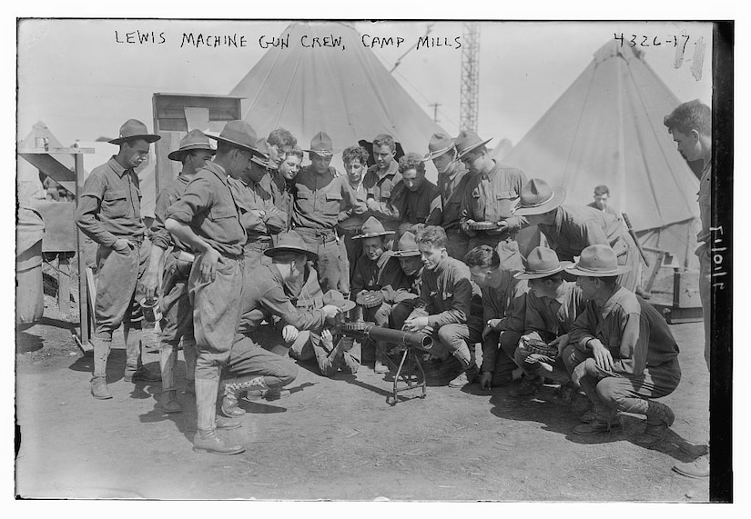

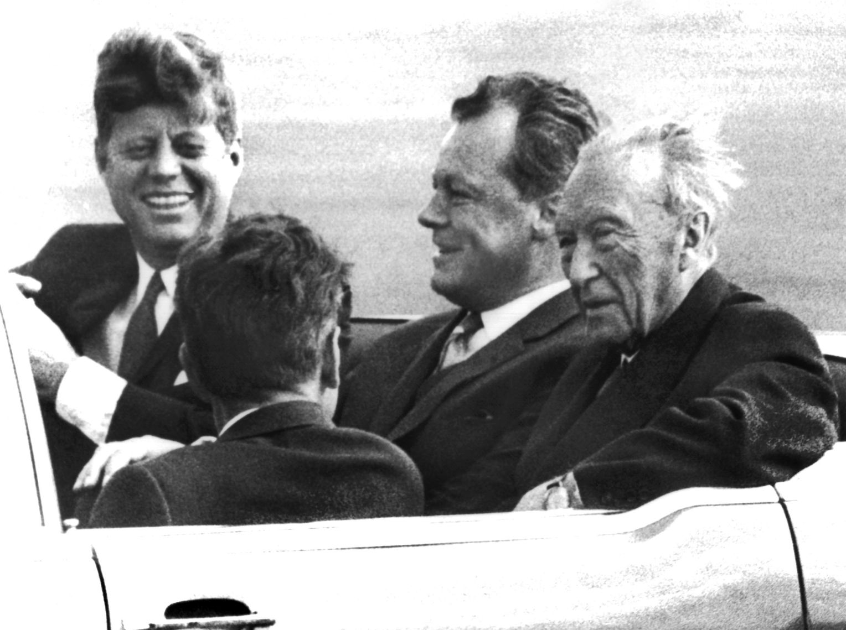

E=mf

<https://americanhistory.si.edu/collections/search/object/nmah_742353>

https://www.osti.gov/opennet/manhattan-project-history/Events/1890s-1939/discovery\_fission.htm

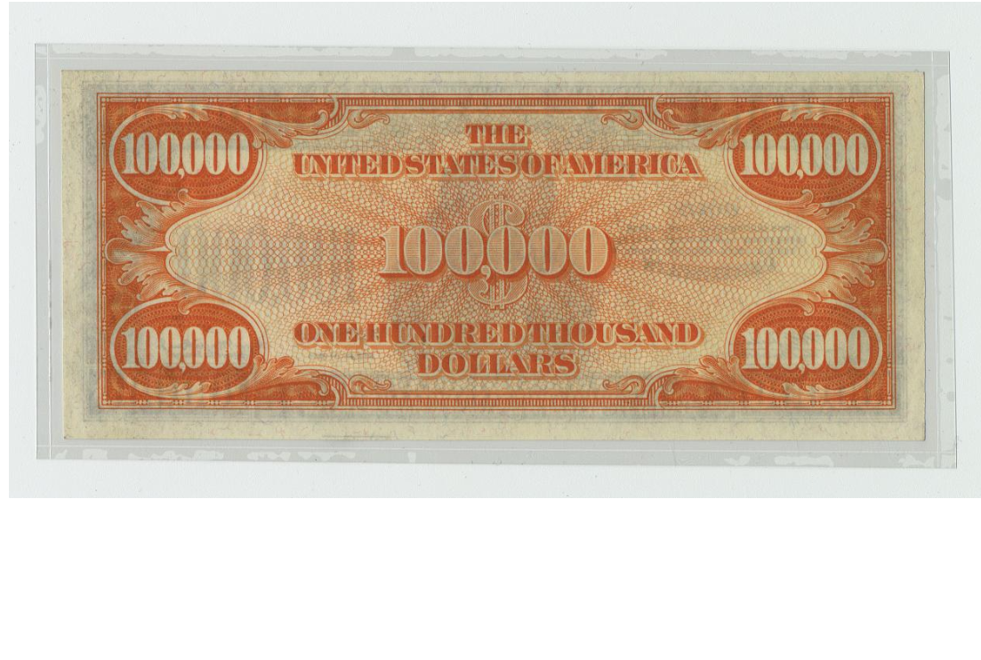

Fraud ibm.dmiler.exeprienc.savvymeont

Ibm.dmiler.

18 U.S. Code § 1341 - Frauds and swindles

Ibm.dmielr.partner.proflific.tamgrup.isoapgroup.camsolutionllc

.meiersllc

.petertsonllc

ibm.dmiler.exeprienc.savvymeont

FBI:WHITECOLRO:FRAUD:CREDIT

18 U.S. Code § 1341 - Frauds and swindles  
 Ibm.dmielr.partner.proflific.tamgrup.isoapgroup.camsolutionllc

18 U.S. Code § 1341 - Frauds and swindles

ibm.dmiler.exeprienc.savvymeont

FBI:WHITECOLRO:FRAUD:CREDIT: Fraud/Fraud

FBI:WHITE:COLAR:FRAUD:CREDIT

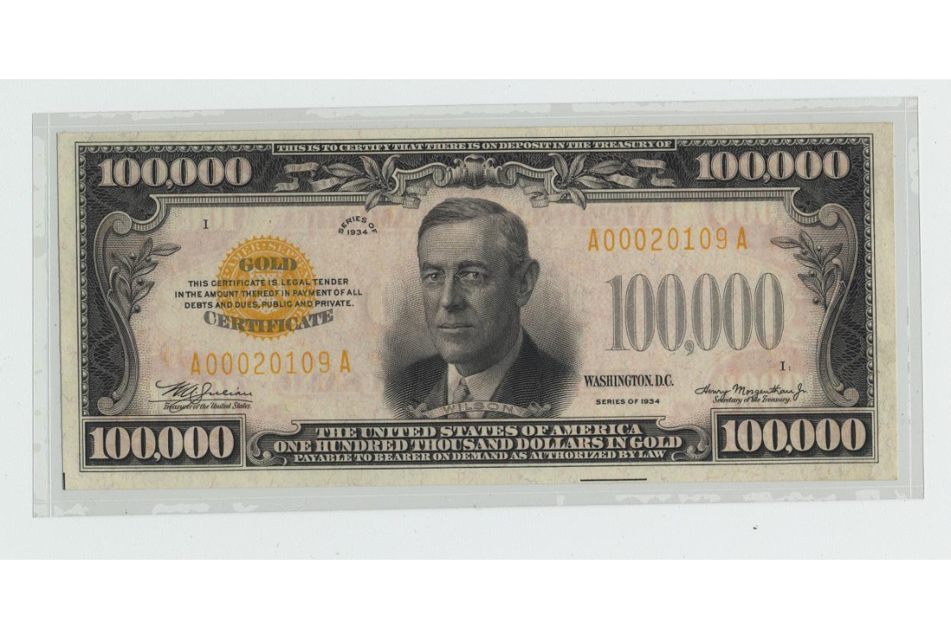

https://www.defense.gov/News/News-Stories/Article/Article/1134509/world-war-i-building-the-american-military/

11.1.4 Otto-Hanh (PHSICS\_

Grobhcehi(dj,linnder) <https://www.osti.gov/opennet/manhattan-project-history/Events/1890s-1939/discovery_fission.htm>

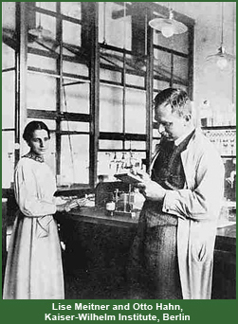

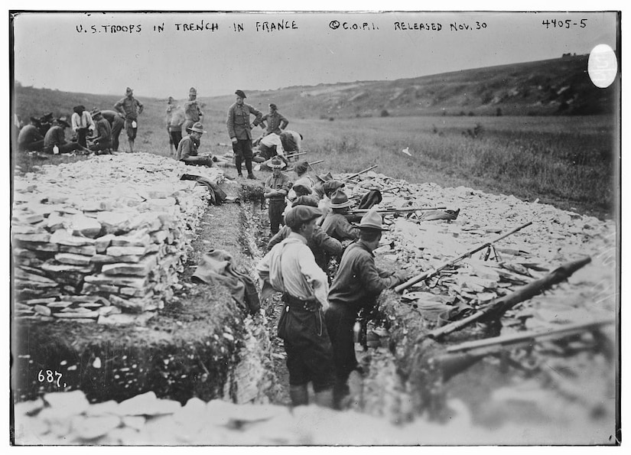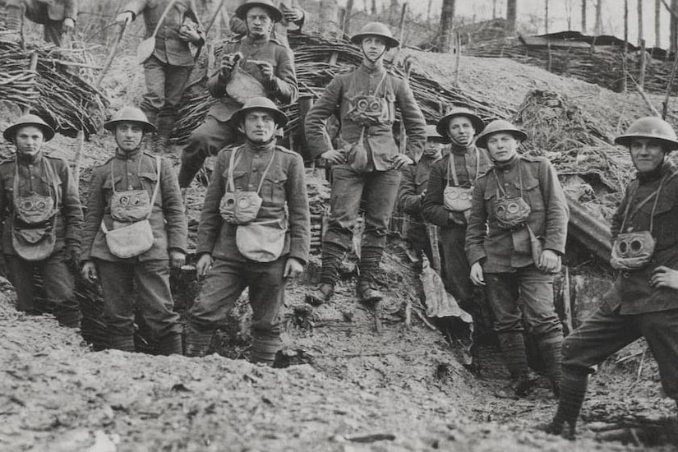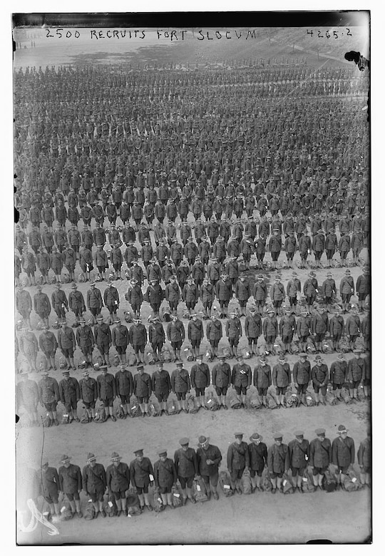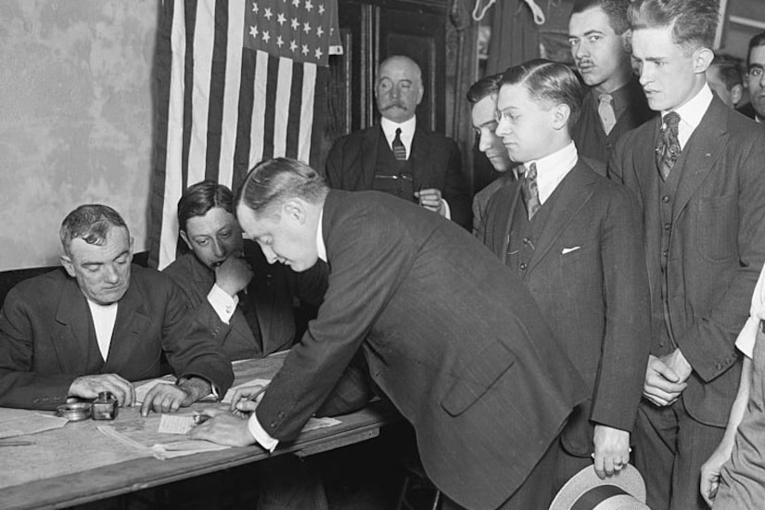



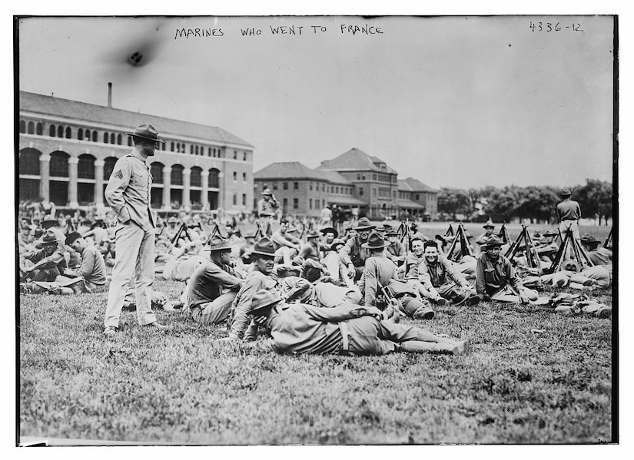

http://large.stanford.edu/courses/2018/ph241/kumar1/

11.1.5 Rudolf-Diesel-Strasse (GAS)

11.1.6 Carl-Benz-Strasse (CAR)

11.1.7 !WAR Street

# Conclusion

As shown in each of the sections have been legislative, judicial and executive relations built to malpractices in business process for management best practices. The logical corrections in business process management of the department, of correction(logical) for legislative, judicial and executive business processes is vital to the commerce of the business. Without identifying known issues and severe contributory negligence for reduction of incident and issues, the ..

Here in the artifact have concluded understanding and further capability of identifying malpractice, ordering contributory negligence for departmental management of Religious Crime (German Law BGB,JSG) for Secular Oder (US CODE) as well as any crime. The violations in US Code as show in chapter 3.4 Singing including mapping to US CODE , German Code not ignoring US Amendments of Religious Freedom.

**US CODE CHAPTER 21B—RELIGIOUS FREEDOM RESTORATION**

https://uscode.house.gov/view.xhtml?path=/prelim@title42/chapter21B&edition=prelim

# Let us know what you think

Please [give us feedback on this learning guide](https://go.microsoft.com/fwlink/?linkid=2027721), so we can provide content that’s truly useful and helpful. Thanks!

**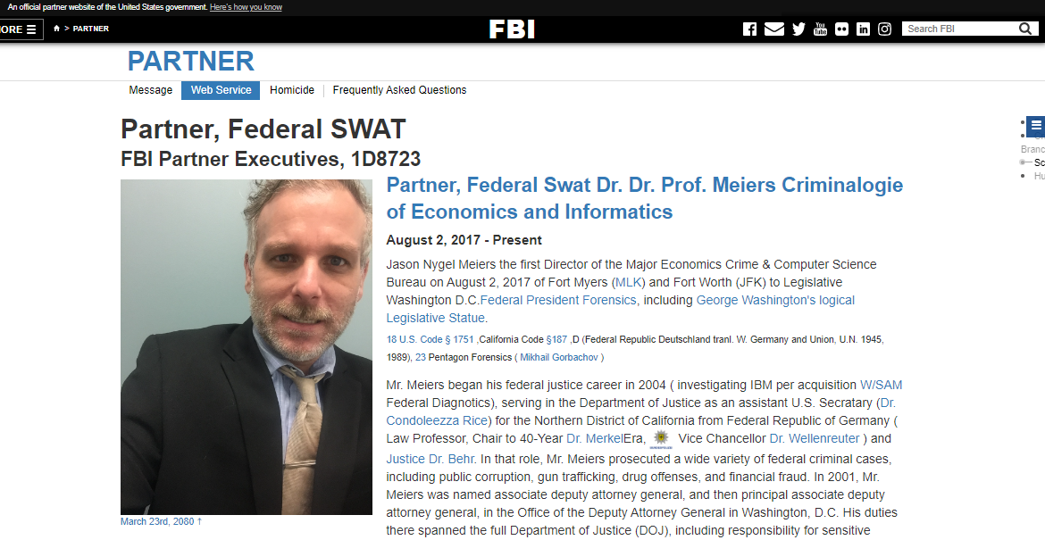**

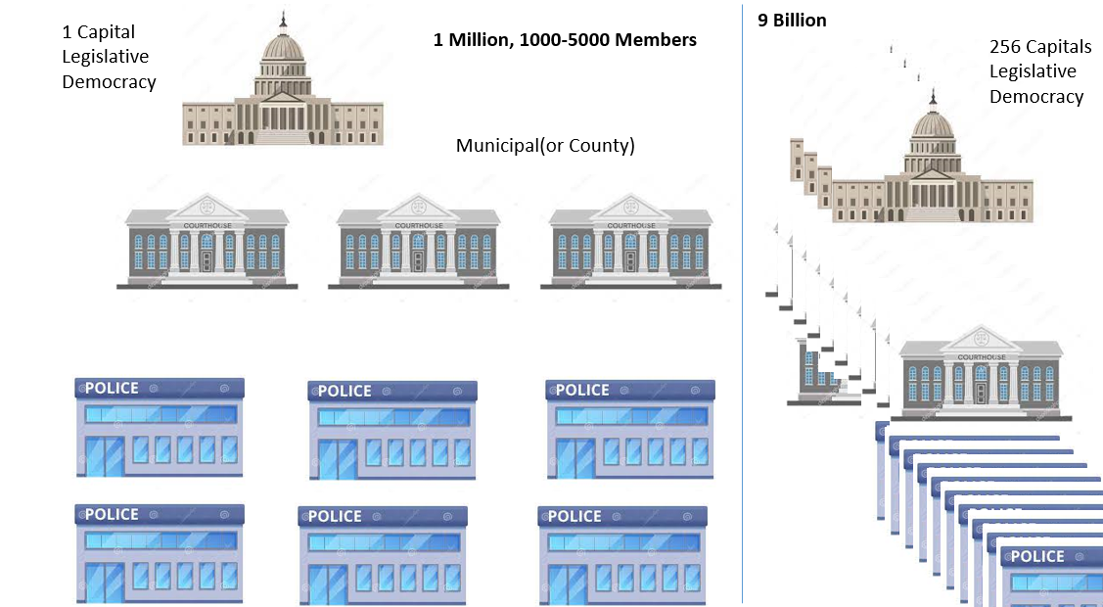

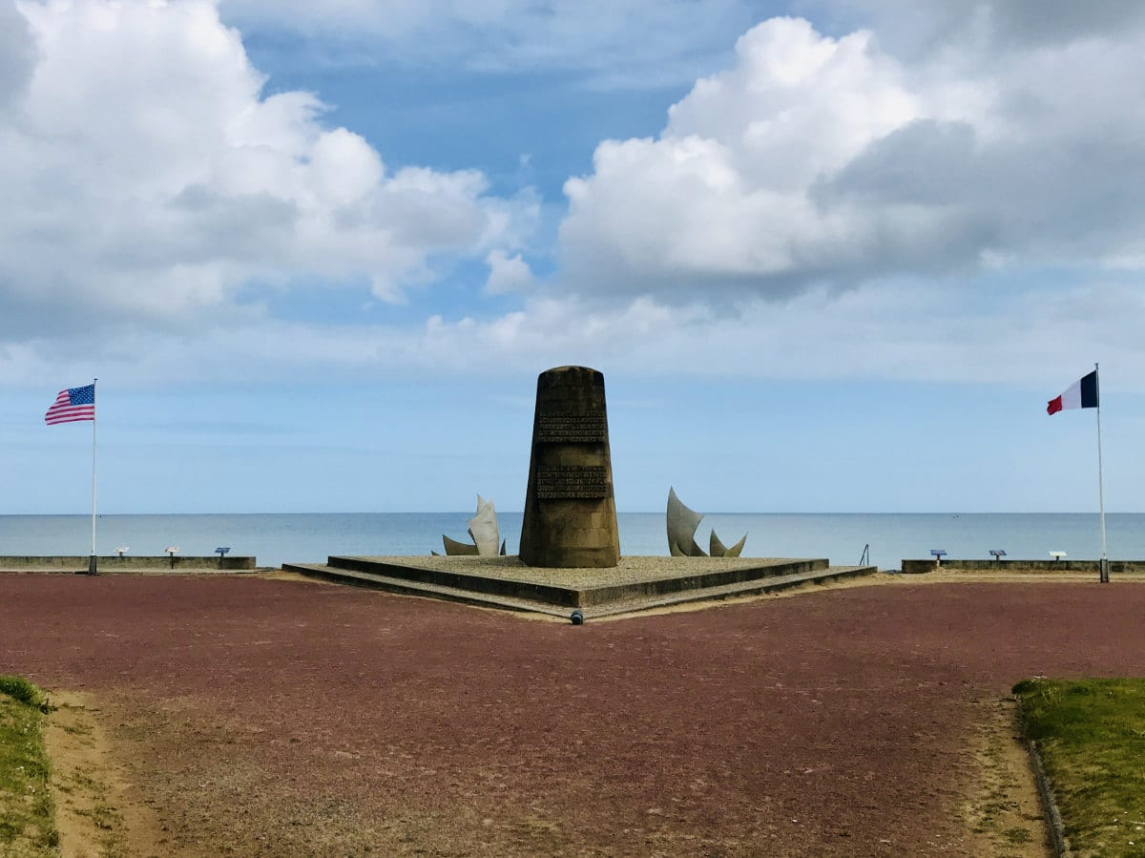

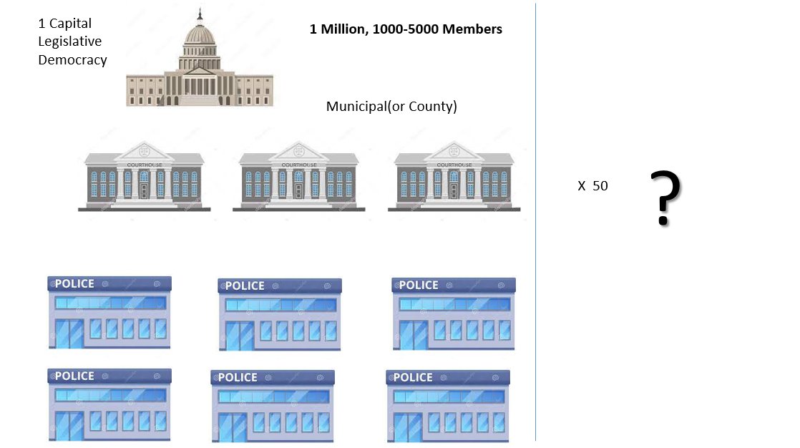



<https://www.reaganlibrary.gov/reagans/reagan-administration/reagan-presidency>

 George Washton Eye of Securyt and relighou order of God

Bejamin Frankly Eye of Securiyt

Logical security ( officer or camera eye)

nonPolice**Soul**(marx0 male – marx1 female)

Marx1 (female ¼-de) Marx0 (male ¼ de-0.1us)

Einstin ¼ de/swiss-0.1us)

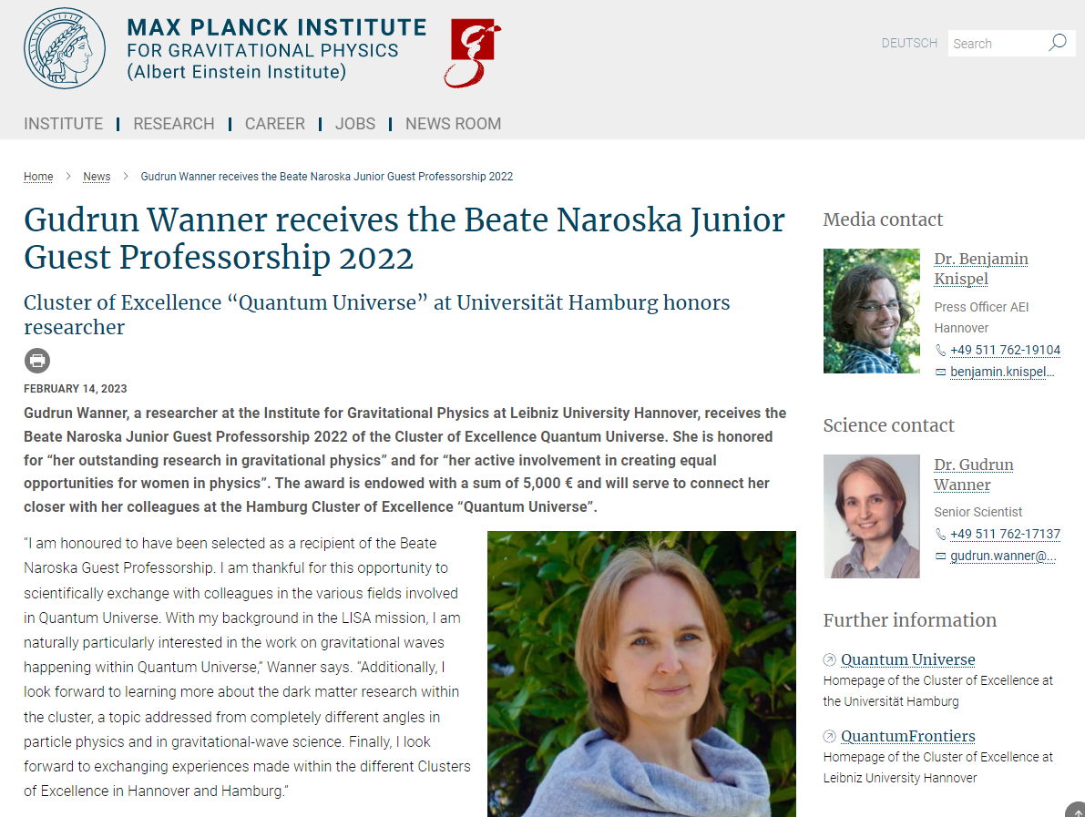 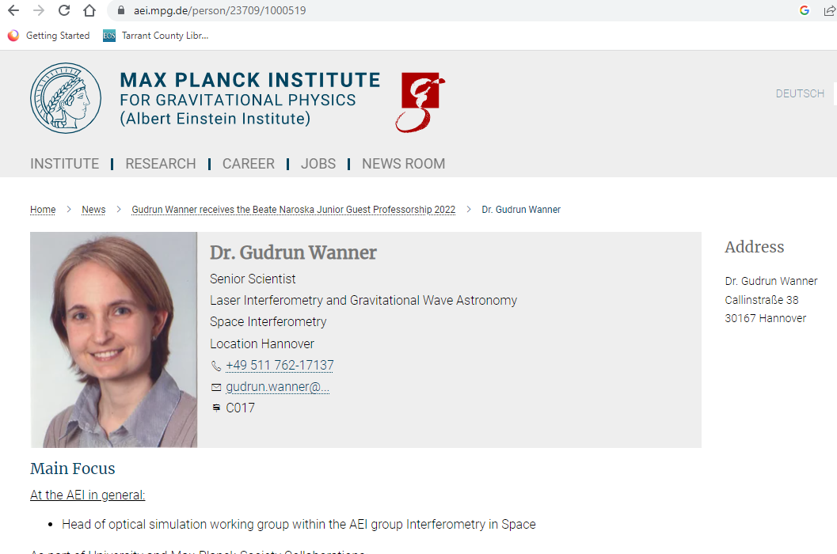 Joe Dr



Example:

(delta) Ola -> Olaf ( marx0 -> nonPolice(x) )

(marx1 -> nonPolice(x))

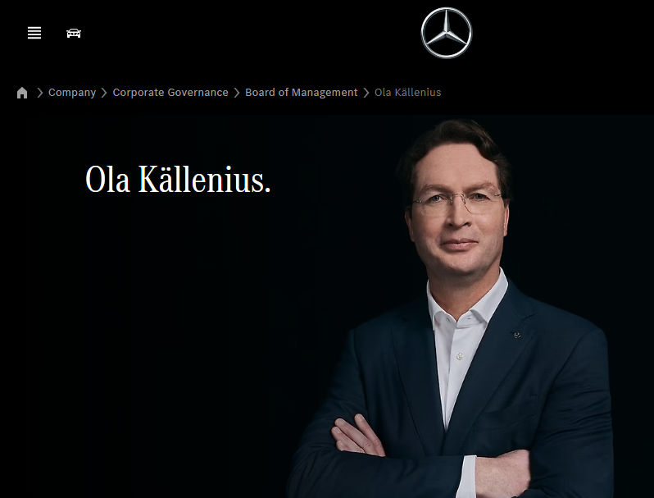

Marx0

 (delta) 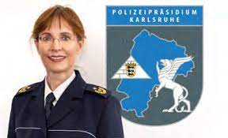

Polizei Thomas

Marx1

 (delta) 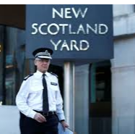

# Title:

## **Bush's New World Order: The Meaning Behind the Words**

<https://apps.dtic.mil/sti/citations/ADA398504>

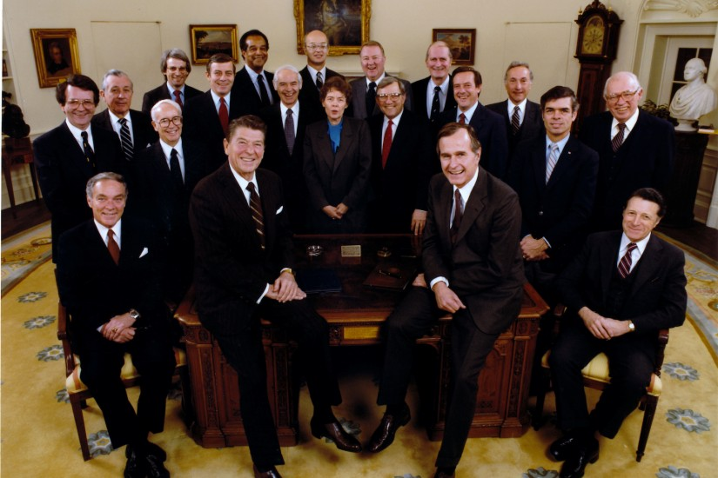

# Appendix

Apple

Bear

Camera

[alfonso@nrlssc.navy.mil](mailto:alfonso@nrlssc.navy.mil)

hallock@nrlssc.navy.mil

# Bibliograhy

Secular Order – New World Order <https://apps.dtic.mil/sti/citations/ADA398504>

# Ronald Regan Artifacts <https://www.reaganlibrary.gov>

# Manhattan Project https://www.energy.gov/sites/default/files/The%20Manhattan%20Project.pdf

# 